

**DRIVEThru Data Analysis Project**

**by Deep Chandra**

**Project Overview:**

DRIVEThru is a multinational transportation company operating in Bangalore, New Delhi, and Mumbai. The company seeks insights into its business performance over the last two years to make data-driven decisions regarding revenue growth, booking cancellations, and customer experience improvements. These findings will also support the company’s expansion strategy.

**Objectives:**

* Assess the company’s performance over two years.
* Identify key factors affecting revenue and bookings.
* Understand the reasons behind booking cancellations.
* Provide actionable recommendations for business expansion.

**Tools Used:** SQL, Python (Pandas, Seaborn, Sklearn), MS Excel, Power BI

**Insights and Reports:**

**1). Revenue Analysis:**

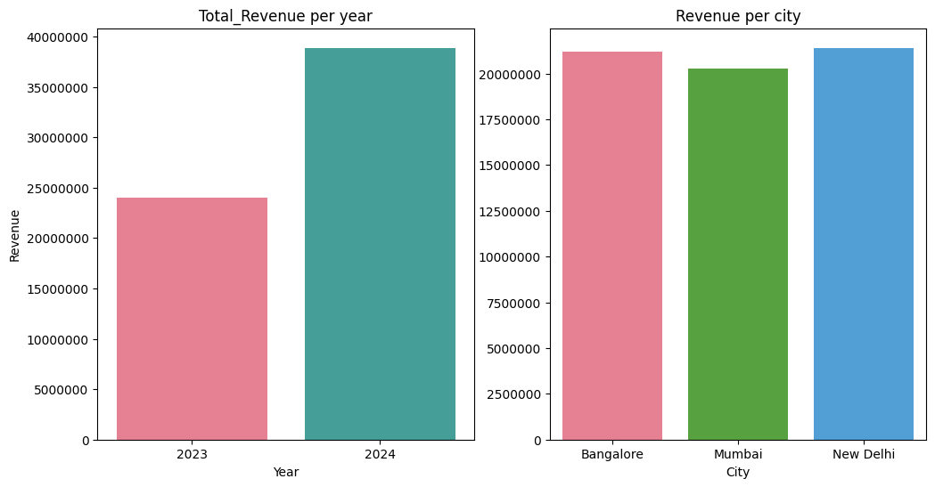

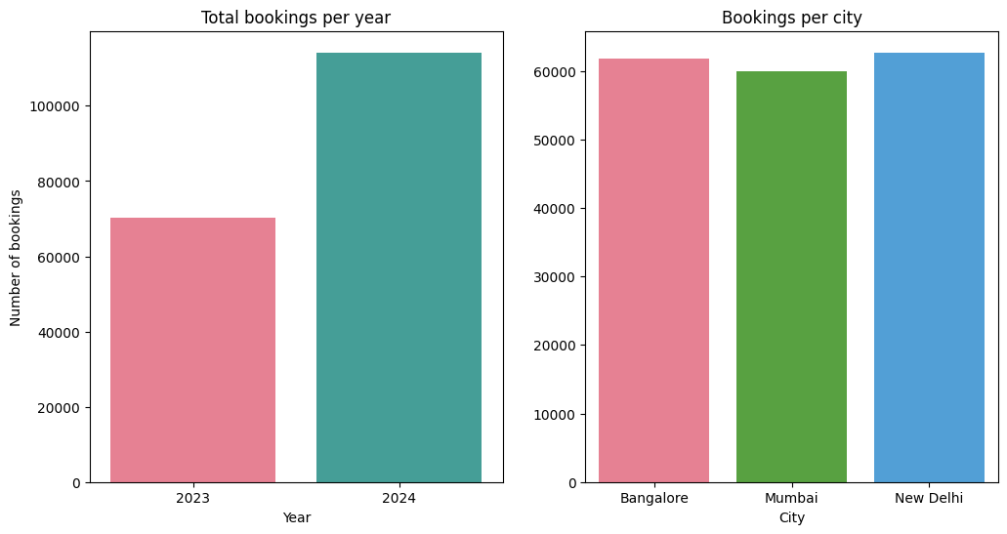

**Key Findings:**

* Revenue surged 62% from 2023 to 2024, driven by strong performance in Bangalore and New Delhi.
* Booking volume also increased by 62%, indicating a growing demand for services.

**Business Insights:**

* The company is on a strong growth trajectory and can consider expanding to new cities.
* Dynamic pricing strategies can be implemented to maximize profitability in high demand areas.

**2). Customer Segmentation (Clustering Analysis):**

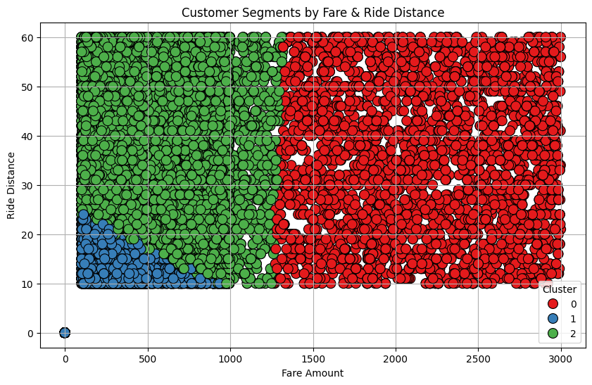

**Key Findings:**

K-Means clustering revealed three distinct customer segments based on ride distance, fare amount, and ratings:

* Cluster 0 : Regular riders with moderate fares and distances.
* Cluster 1 : Frequent short-distance riders with lower fares.
* Cluster 2 : High-value customers who take long-distance, high-fare rides.

### ****Business Insights:****

* **Target High-Value Customers (Cluster 2):** Offer loyalty programs and premium ride options.
* **Optimize Pricing for Short-Distance Riders (Cluster 1):** Introduce dynamic pricing for better profitability.
* **Improve Customer Experience (Cluster 0):** Use targeted marketing and discount offers to increase engagement.

## **3). **Cancellation Analysis (Correlation Study):****

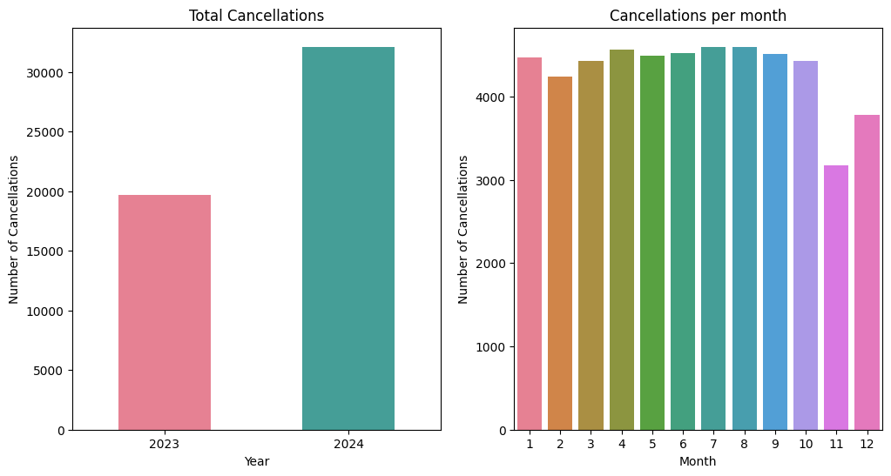

**Key Findings:**

The number of cancellations increased by almost 63% in 2024 from the previous year. If we analyze the cancellations per month, the number of cancellations remained relatively constant from January to October and it starts to decrease from November. In November, the cancellations were the lowest.

**Correlation Analysis:**

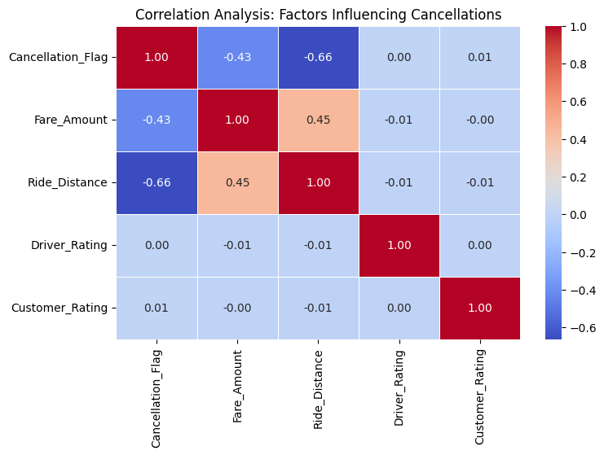

**Key Findings:**

* **Ride Distance (-0.69 correlation):** Longer ride distances demonstrated a strong negative correlation with cancellations, indicating higher ride completion rates.
* **Fare Amount (-0.46 correlation):** Higher fares reduce cancellation rates.
* Driver & Customer Ratings have minimal impact on cancellations.

**Business Insights:**

* **Reduce Short-Distance Cancellations:** Offer driver incentives for accepting short rides.
* **Optimize Pricing:** Introduce penalties for cancellations on low-fare rides.
* **Improve Driver Engagement:** Provide bonuses or ride priority for consistent drivers.

**4). Bookings Status Comparison:**

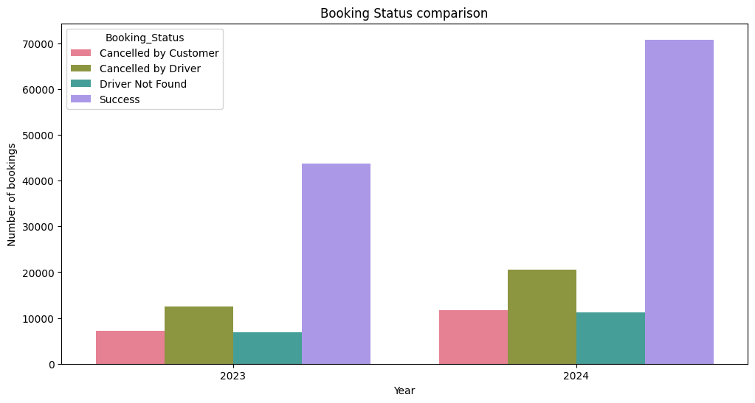

**Key Findings:**

The number of bookings cancelled due to “Cancelled by Driver” and “Driver Not Found” increased in 2024 from the previous year.

To reduce cancellations, the company should focus on addressing the top reasons such as **'Cancelled by Driver'** and **'Driver Not Found'**.

**5). Revenue generated per Vehicle Type comparison:**

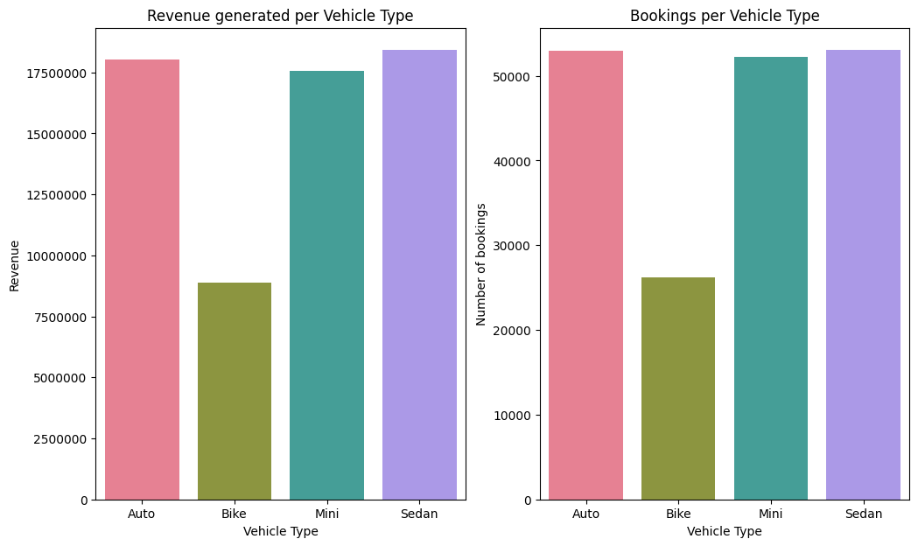

**Key Findings:**

* The Sedan category generates the highest revenue, while the Bike category contributes the least.
* Auto and Sedan categories are the most preferred by the customers for bookings. Additionally, the Bike category records the lowest number of bookings, indicating a need to boost customer interest.

**Final Recommendations:**

* As the cancellations are more from the drivers, the company can conduct targeted training programs for drivers to reduce cancellations. Penalties could be **introduced** for frequent cancellations to discourage this behavior.
* For the cancellations under the reason of “Driver not found”, the company should aim to onboard more drivers and connect additional vehicles to its platform. The company can launch promotional campaigns and offer joining bonuses to attract more drivers.
* The company should refine its pricing strategies for the Bike category or give some offers to the customers so they can book more Bike rides.
* As the revenue is increasing and the number of bookings are also increasing, the company can plan to expand their services in other cities and also can introduce more vehicle categories.
* Implement dynamic pricing strategies to optimize earnings across different ride segments.